25th February 2025

Dear Parents and Carers,

**STAFF RIGHT TO PRIVACY**

As you know, we deeply value the partnership we share with our pupils and their families. It is only by working together that we can strive to create a nurturing and supportive environment for our children to learn and grow. We thank the vast majority of our parents, carers and pupils who are role models and ambassadors for our schools in our communities and the supportive manner in which you work with us as parents and carers to support your children.

However, it has come to our attention that a small minority of our school pupil community has been targeting the homes of school staff, often late at night, in a manner which is deemed hostile, threatening and seeking to intimidate members of staff and their families. Unfortunately, we are also shocked to have learnt that staff personal details and addresses have been shared by parents on social media platforms. As you will appreciate, this has been extremely upsetting and an intimidating time for staff and their families, and I am sure you will agree that this is something which is totally unacceptable and cannot be tolerated by our schools or the Trust.

All our staff members are dedicated professionals who work tirelessly to provide the best education and support for your children. When their privacy is compromised, it not only affects their well-being but also the well-being of their families. It is important for our staff to have a safe and private space where they can relax and recharge.

We kindly request that you speak to your children about respecting the privacy of our staff and their families and remind them that there are no circumstances where it is acceptable to target staff in their homes or whilst they are out in the community going about their day-to-day life. Please can we ask that you also consider the use and sharing of content on social media and messaging platforms and the impact that inappropriate messaging can have.

Any matters that are brought to our attention will not be tolerated in any form by our schools or the Trust and we will put in place immediate steps to protect our employees from being subject to such conduct. All instances will be reported through the appropriate channels, including the police, and relevant sanctions will be undertaken through our internal processes, including the Schools’ Behaviour for Learning Policy, pupil & parent charters and the Trust’s Threatening, Abusive and Aggressive Visitors and Parents Policy.

We take no pleasure in writing to you in these terms and we have never had to do so before. However, the conduct of a small minority of pupils and parents has exceeded what we as a Trust or any school are prepared to tolerate, and I would ask that you take time to reflect how such actions can impact on our staff and their families so we can move forward together in a productive and respectful way.

Thank you for your understanding and cooperation in this matter. Together, we can ensure a positive and respectful environment for everyone in our school community. We encourage you to reach out to us through the appropriate school channels if you have any concerns or should you need to discuss any matters.

Yours faithfully,

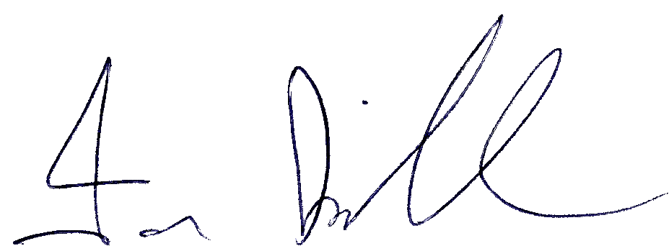

Ian Kirkham

Chief Operations Officer