Year 6 to 7 Maths Transition Booklet

Key Skills

Before you move up to year 7 it would be great if you could make sure that you are confident with these key maths skills:
- Times tables recall
- Addition
- Subtraction
- Multiplication
- Division
- Simplifying fractions
- Calculating basic percentages of amounts
- Rounding to the nearest whole number, ten and hundred

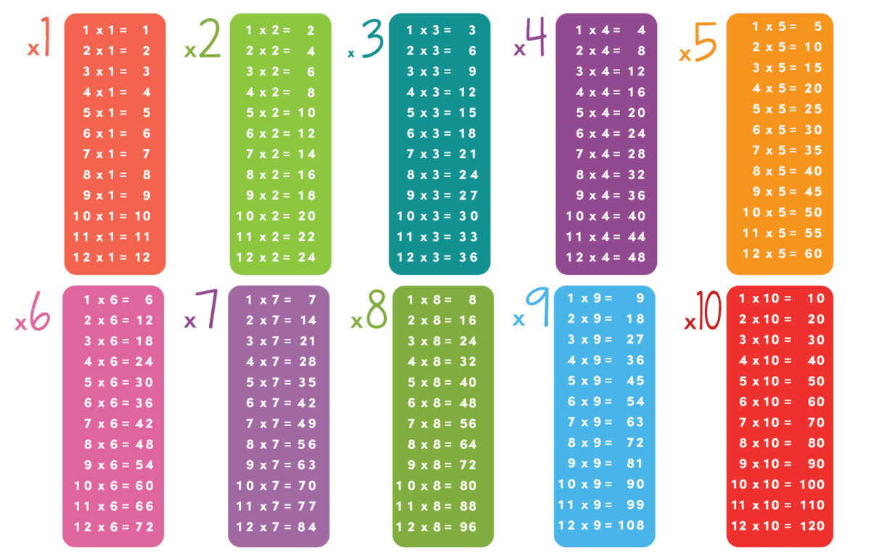
In this booklet you will find a section on each of these topics with the answers provided too so that you can practise. There is also information at the end of the booklet on a free Hegarty maths course specifically for Year 6 pupils.

Times Tables

Complete the following questions after you have looked at the times tables on the previous page.

Times Tables Answers:

Addition
Example:
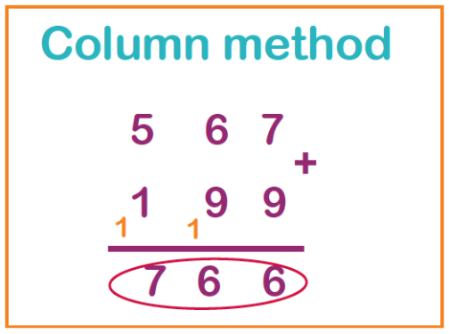

Addition Answers:

Subtraction
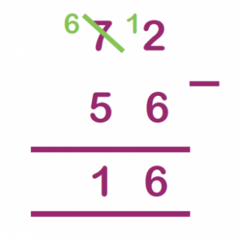
Example: Column subtraction

Subtraction Answers:

Multiplication
Example: Column multiplication
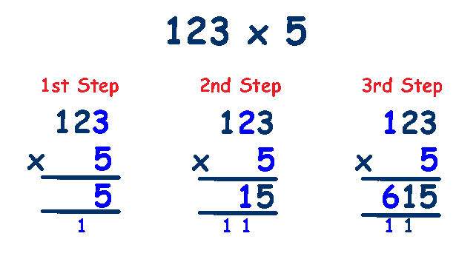

Section 1:

Section 2:

Section 3:

Multiplication Answers:

Section 1 Answers:

Section 2 Answers:

Section 3 Answers:

Division
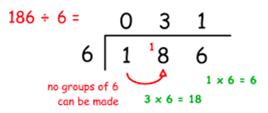
Example: Short division using the bus stop method

Division Answers:

Simplifying Fractions
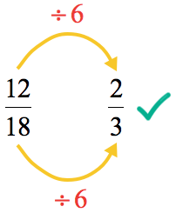
Examples:
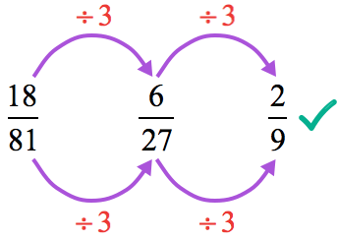

Simplifying Fractions Answers:

Calculating Percentages
Examples:
50% - To find 50% we divide our amount by 2 so
50% of 30 = 30 ÷ 2 = 15
25% - To find 25% we divide our amount by 4 so
25% of 30 = 30 ÷ 4 = 7.5
10% - To find 10% we divide our amount by 10 so
10% of 30 = 30 ÷ 10 = 3

Calculating Percentages Answers:

Rounding
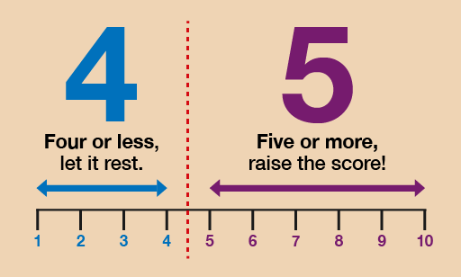
Rule:

Section 1: To the nearest whole number

Section 2: To the nearest ten
Section 3: To the nearest hundred

Rounding Answers:

Section 1 Answers:

Section 2 Answers:

Section 3 Answers:

Along with this key skills booklet you can also sign up to the following on Hegarty maths for free.

Secondary Ready is a course that Year 6 learners can access free-of-charge to help them prepare for starting Year 7 in September.
Being up-to-speed in maths when starting secondary school is really important. Things like core number skills are really vital to make sure that when they start moving on to more challenging concepts, they have a solid foundation. It’s also really important to make sure that your child doesn’t have any gaps in their knowledge and some regular practice over the summer will help ensure that the core skills don’t get forgotten.
Numerise’s Secondary Ready course covers topics like geometry and statistics that your child will have covered at primary school to make sure that their learning stays interesting and varied.
Features
- Designed specifically to prepare children for starting Year 7
- Varied questions keep learners engaged and motivated
- Help videos are available for when a child gets stuck
- Use on a desktop, laptop, tablet or mobile – whichever suits you
- Powered by Sparx Maths, which improves progress in maths
https://learning.sparx.co.uk/secondary-ready?utm_source=Numerise-com&utm_medium=Website&utm_campaign=Secondary-Ready&__hstc=160263458.238aa9eb074647fa8d247c6d3abba23f.1589798467726.1589798467726.1589798467726.1&__hssc=160263458.1.1589798467727&__hsfp=630254131

